Daniel Lara - ID: 49651280

Zachary Hart – ID: 70953123

CS 132

HW 2: Wireshark Labs

# Question 2: Wireshark Labs

## HTTP:

1. Is your browser running HTTP version 1.0 or 1.1? What version of HTTP is the server running?

**Answer: Both the browser and the server are using version 1.1.**

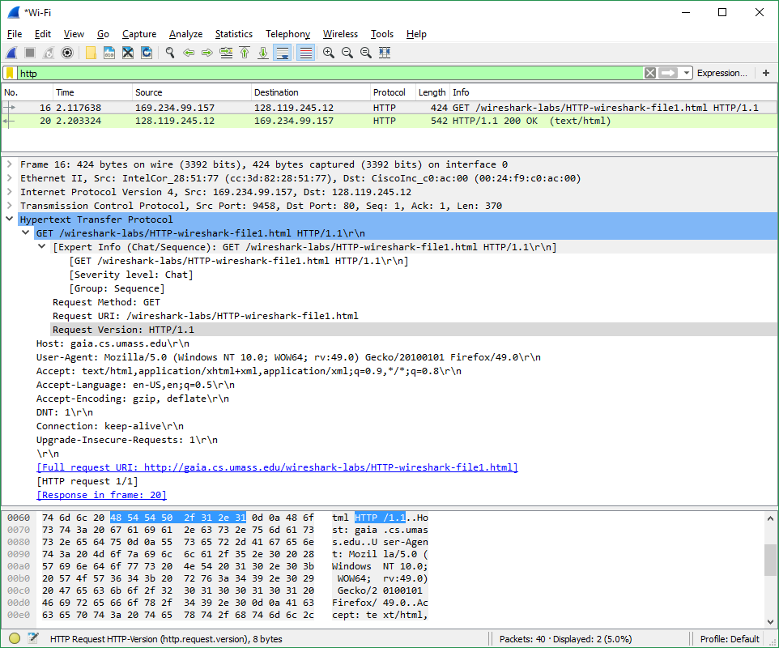



1. What languages (if any) does your browser indicate that it can accept to the  
   server?

**Answer: en-US, en**

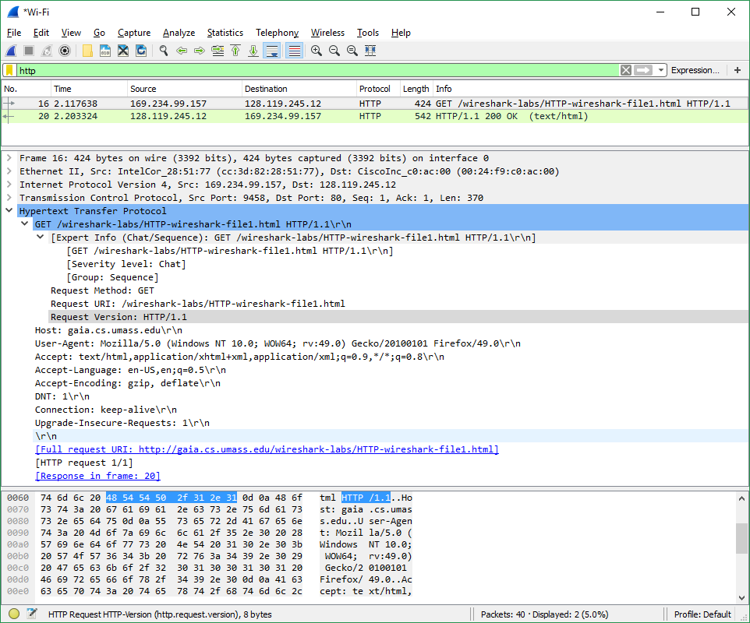



1. What is the IP address of your computer? Of the gaia.cs.umass.edu server?

**Answer: My IP = 169.234.99.157 Edu IP = 128.119.245.12**

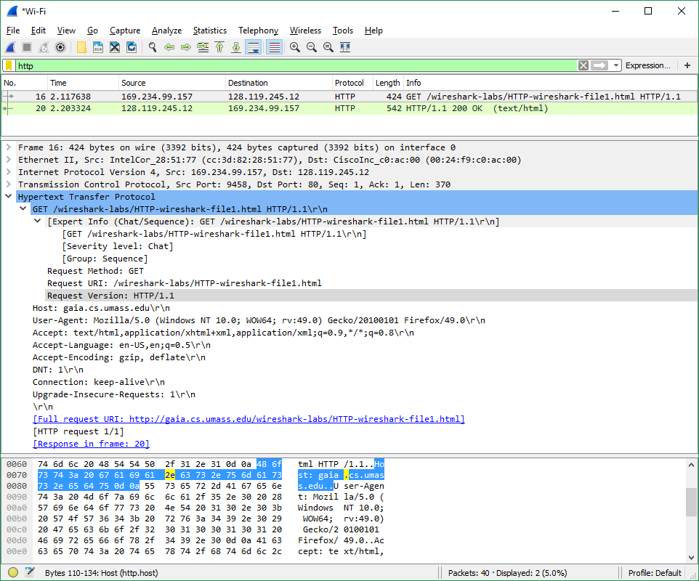



1. What is the status code returned from the server to your browser?

**Answer: HTTP/1.1 200 OK (Status Code: 200, Response Phrase: OK)**

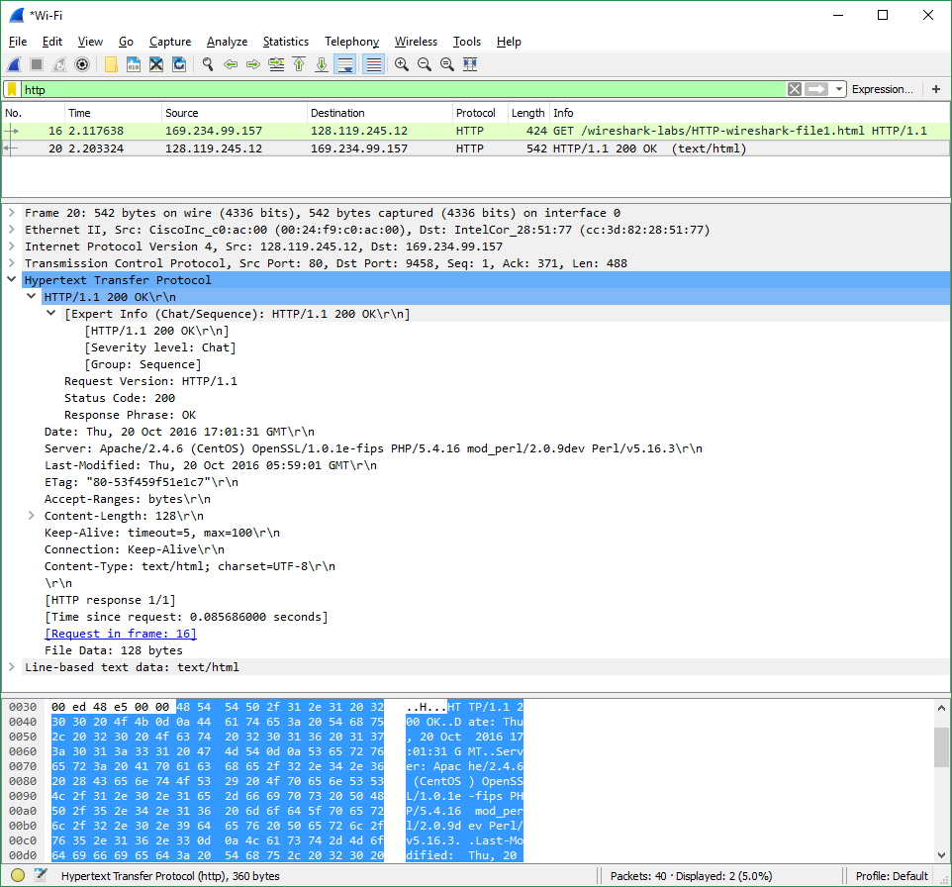



1. When was the HTML file that you are retrieving last modified at the server?

**Answer: Thu, 20 Oct 2016 05:59:01 GMT**

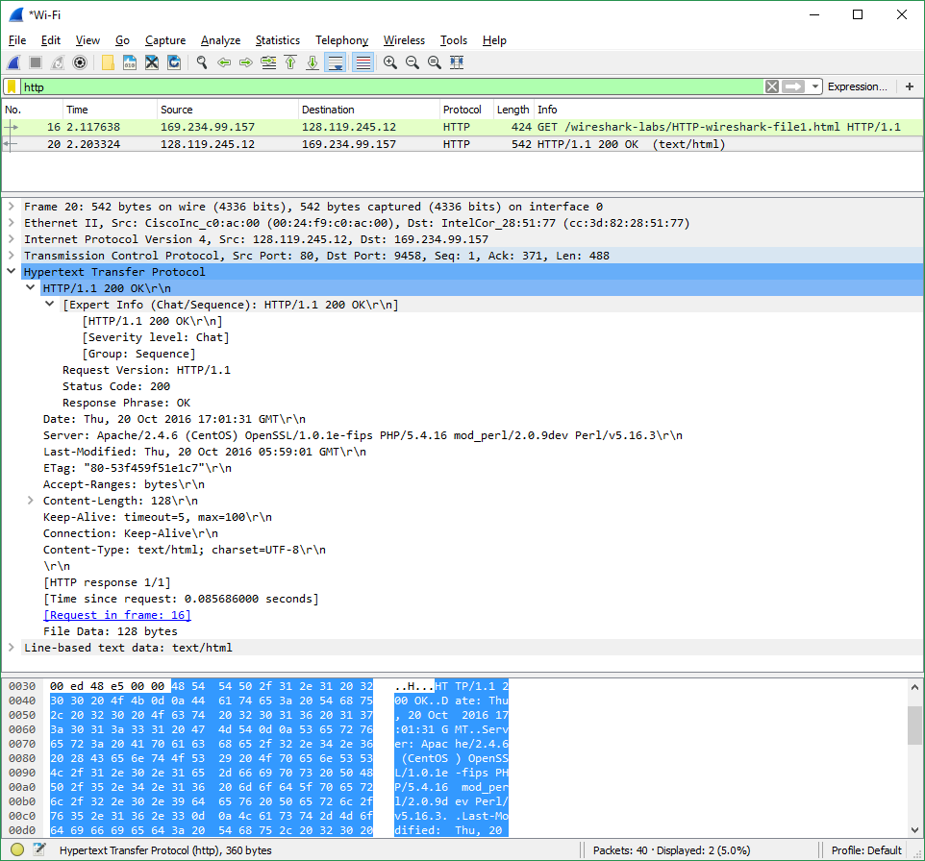



1. How many bytes of content are being returned to your browser?

**Answer: Content-Length: 128 (128 bytes)**

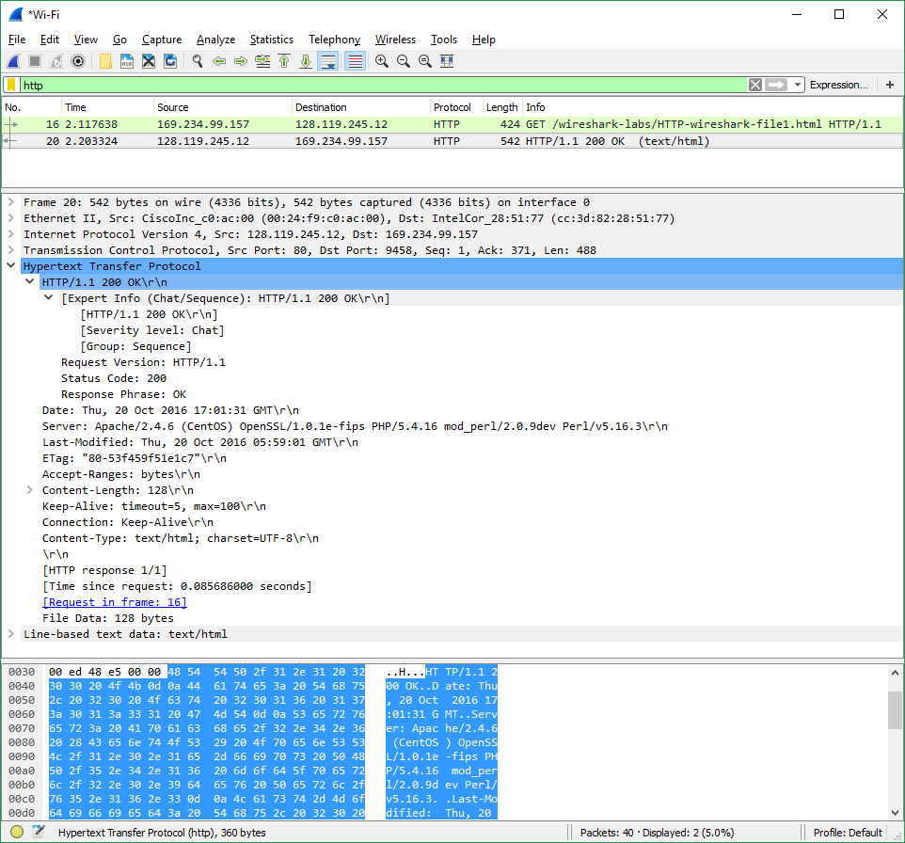



1. By inspecting the raw data in the packet content window, do you see any headers  
   within the data that are not displayed in the packet-listing window? If so, name  
   one.

**Answer: No. All the headers are accounted for in the raw data.**